05/10/2026 - Task
Completed By:Vimala Rani A(212223040240)

1.Using Selenium WebDriver, automate the login process of the SauceDemo website by entering the valid username and password and clicking the Login button.

Expected result:
The user should be successfully redirected to the Products page.
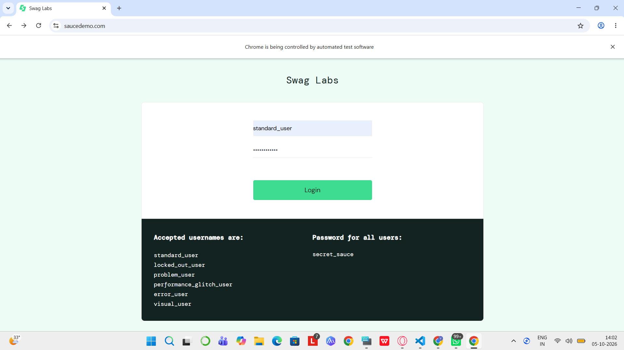

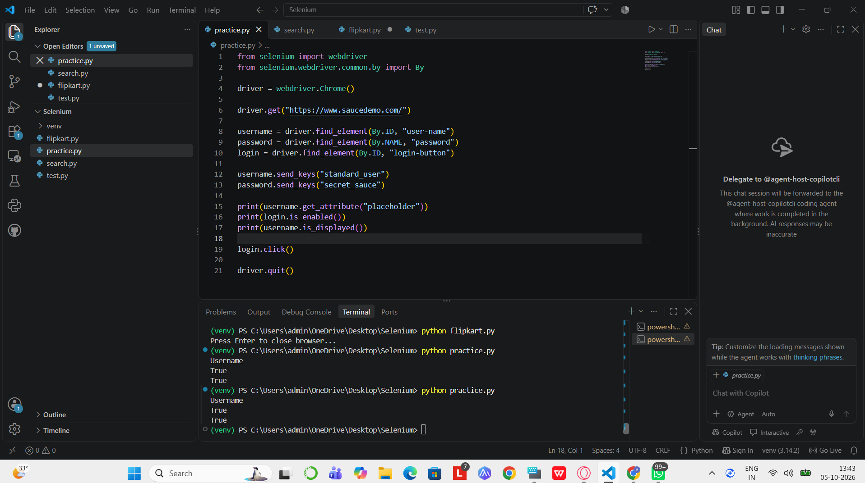
2.Using Selenium WebDriver, automate the SauceDemo website and retrieve and display the list of all available products after successful login.
Expected result:
The names of all products available on the Products page should be displayed in the console.
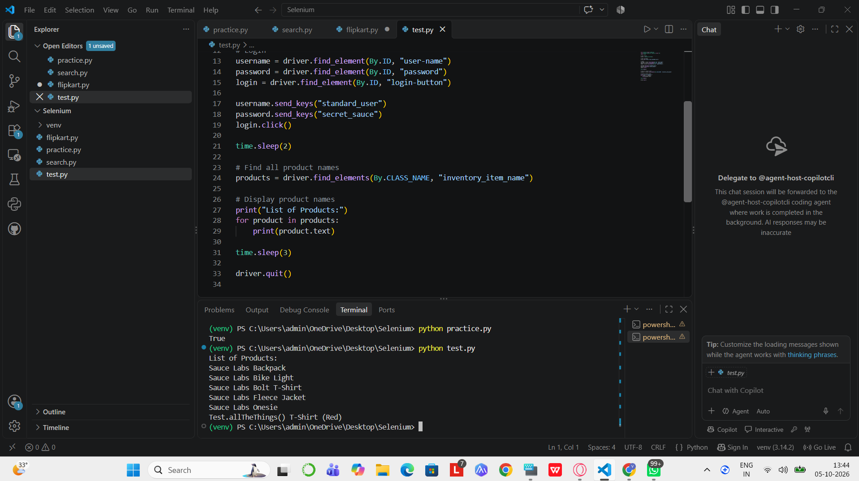
3.Using Selenium WebDriver, automate the Flipkart login process by opening the website, clicking the Login button, entering the registered mobile number, and proceeding to OTP verification.
Expected result:
The login page should accept the mobile number and proceed to the OTP verification screen. The OTP can be entered manually for security.
